**October 30th**

**Doors open at 12 Noon**

* **Tips, Basket Auction, & 50/50 drawing**
* **Kitchen & Bar open\***

**BINGO Starts at 1 pm**

*\*Food & Drinks are available for purchase - No outside food/drinks are permitted*

**2022 Bethany Bash at**

**Polish Falcons**

**431 E 3rd St.**



Dear Friends of Bethany Outreach Center,

Bethany Outreach Center is located at ground zero for poverty in Erie County. Our neighbors, many of whom are children, inhabit an area more blighted than 99% of the United States. We exist for one reason only, to improve the lives of our neighbors through hands-on ministry.

Like most of the neighbors we serve, Bethany Outreach Center owns very little. We rent space, we have no mortgage, the furniture and office equipment have seen better days. We have one part-time executive director and one part-time executive assistant both of whom work wonders in finding and inspiring volunteer help. Last year (2021) volunteers gave 4,098 hours of their time!

With these volunteers our food pantry opens its doors weekly to provide much needed food items during the calendar year, including Thanksgiving dinner items. Our clothes closet provides, free of any charge, clothing appropriate to the changing seasons. During the Pandemic we had the additional challenge every week of providing this food and clothing outside in the fresh (and sometimes freezing cold) air. Our clients made their selections from over 26,911 pounds of donated clothing last year. Because many of our neighbors are newly arrived immigrants, including Ukrainians, we provide a variety of household necessities -- again free of any charge. We now offer additional programs in healthy living, community service for students, and service learning projects for children. Last year 1,132 households, including 350 children were served by the programs offered at the center.

On October 30th, we will invite the local community to attend our “Bethany Bash” fundraising event. Those attending will enjoy games of BINGO, tip boards, a Basket Auction, pull tabs and a 50/50 drawing. This is sure to be a popular event with the local community.

We are hopeful that you will agree to partner with us by being a sponsor of our event, or by donating one or more items for our Basket Auction. Please complete the enclosed Commitment Form and return it as soon as possible. When you participate, rest assured that the dollars you provide will be used in personal face to face ministry with cost effectiveness second to none.

Thank you for your support,

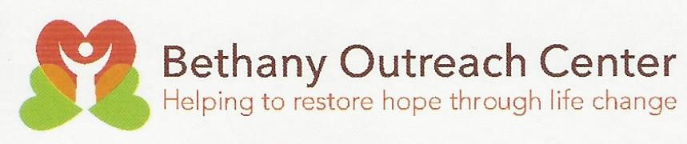

**Carol Gleichsner**

Carol Gleichsner

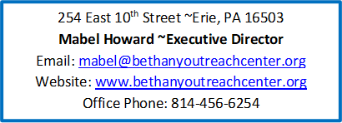Board Chair

[carol@bethanyoutreachcenter.org](mailto:carol@bethanyoutreachcenter.org)

